# **Name: Abdurrahman Qureshi**

# **Roll No: 242466**

Practical No: 1

Steps to install Unix on your pc.

Download and Install VirtualBox from the official website.

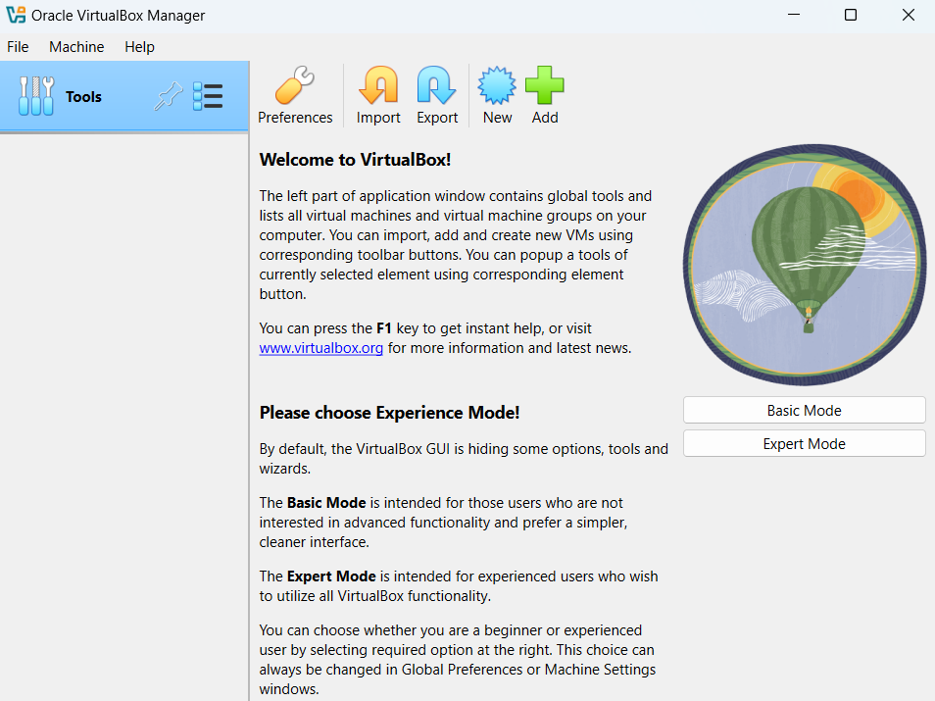

Creating a new virtual machine.

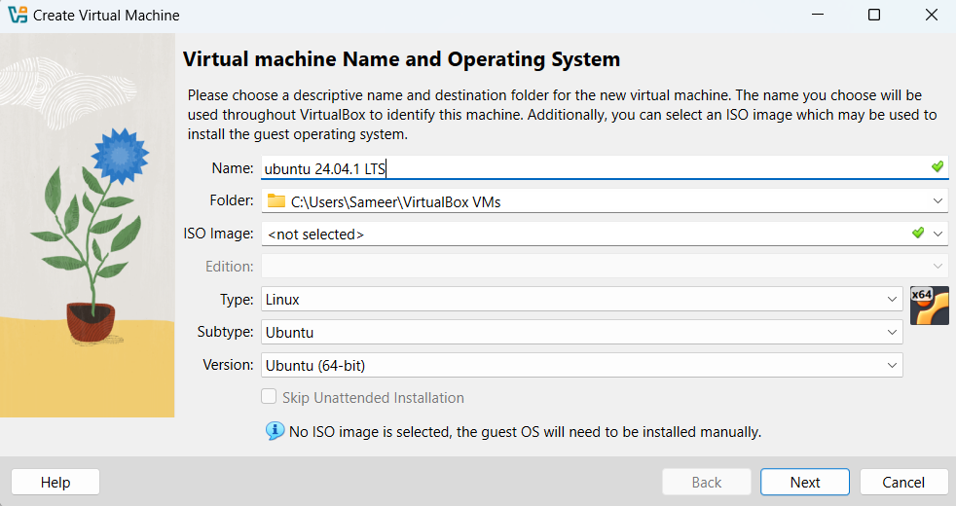

Providing the required settings for the installation of virtual machine.

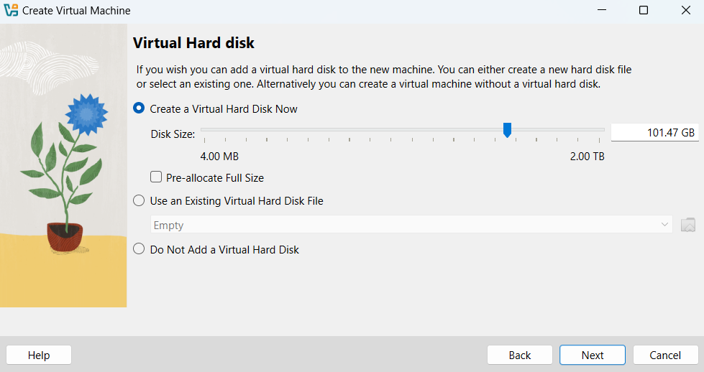

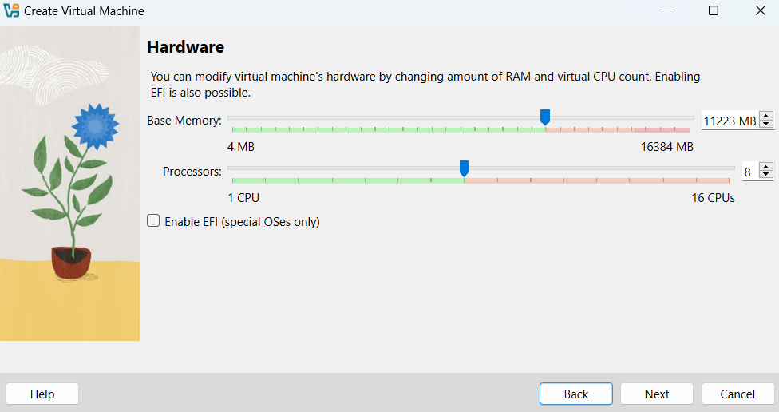

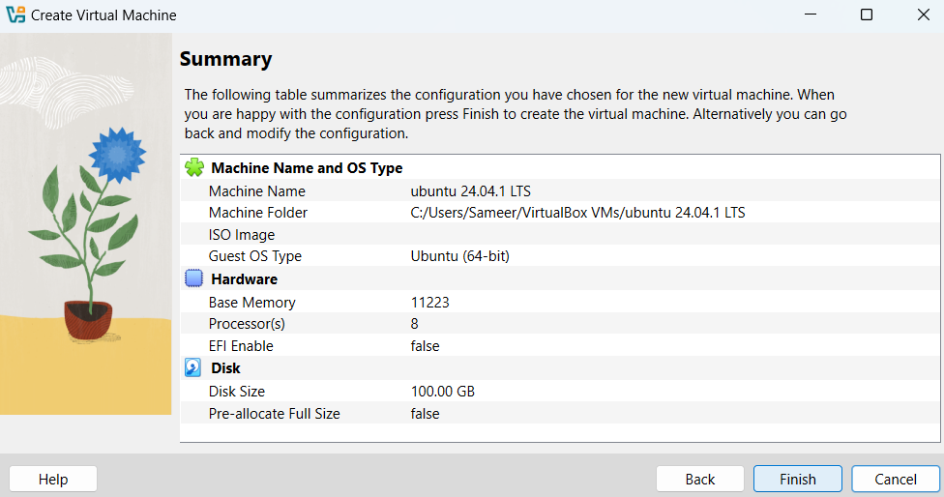

Click start to initialize the setup of Ubuntu. Add the downloaded “ubuntu.iso” file to the controller:IDE.

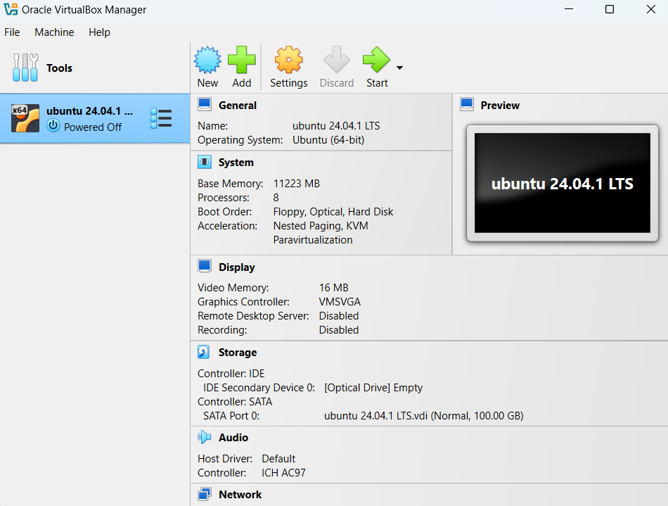

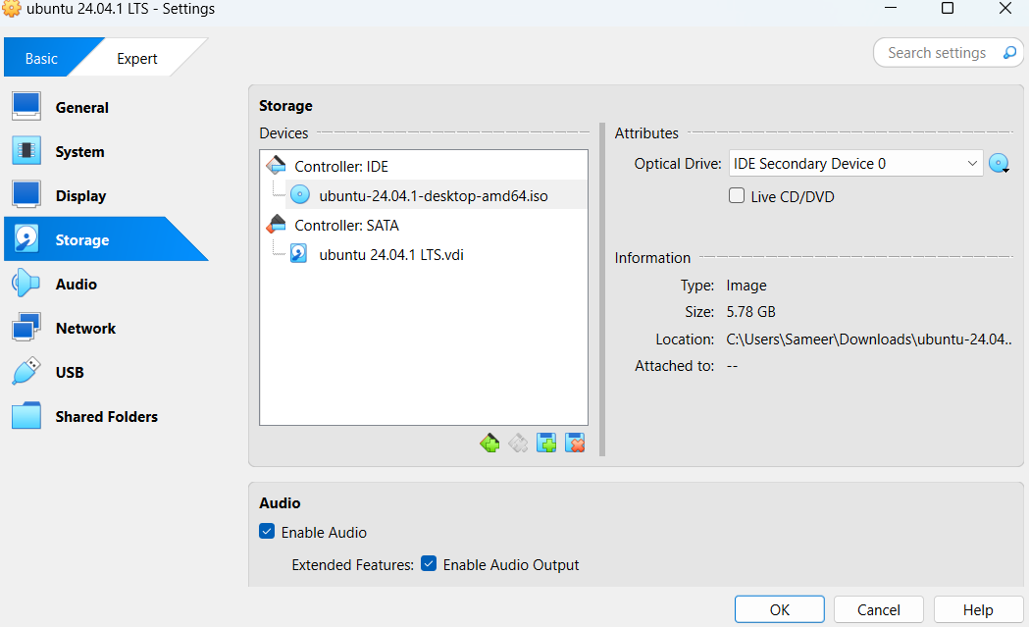

Installing Ubuntu in our system.

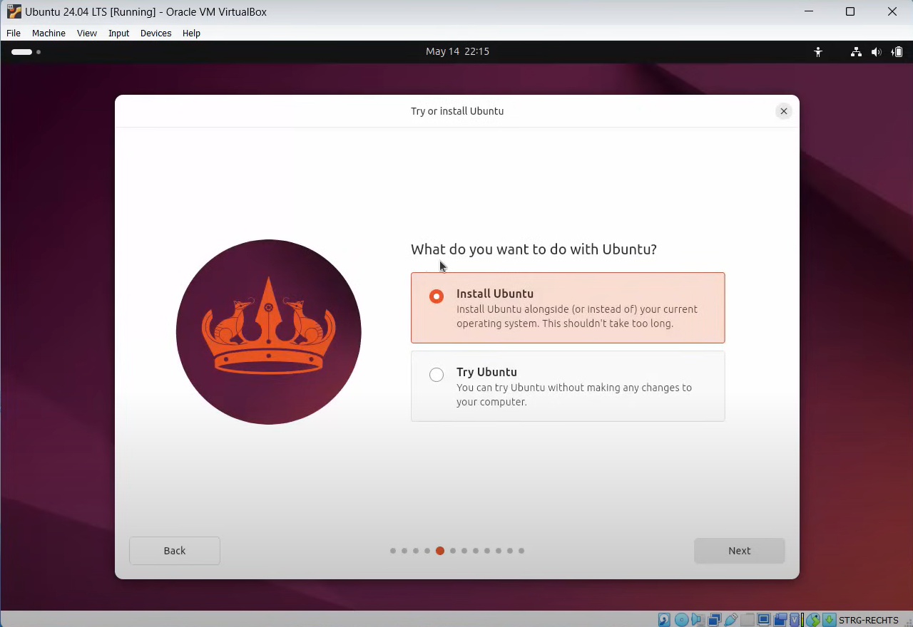

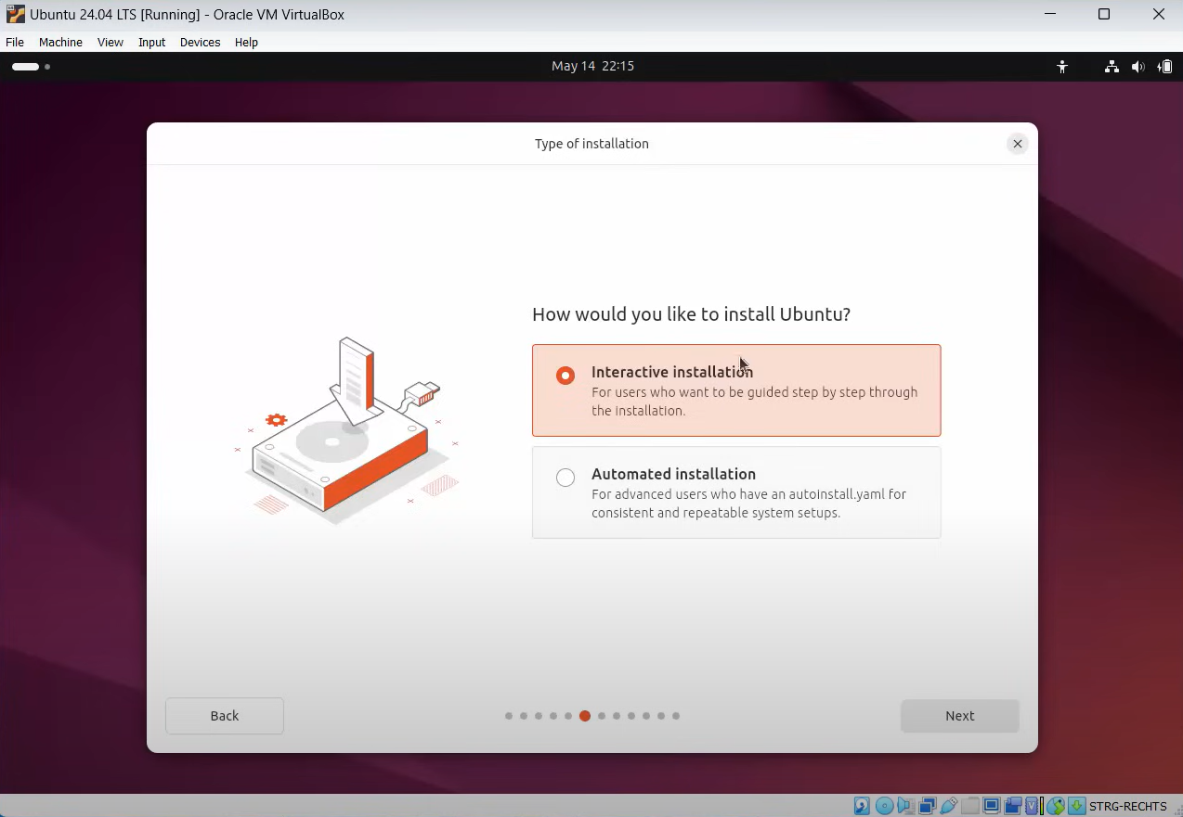

Installing third-party software and support for additional media files.

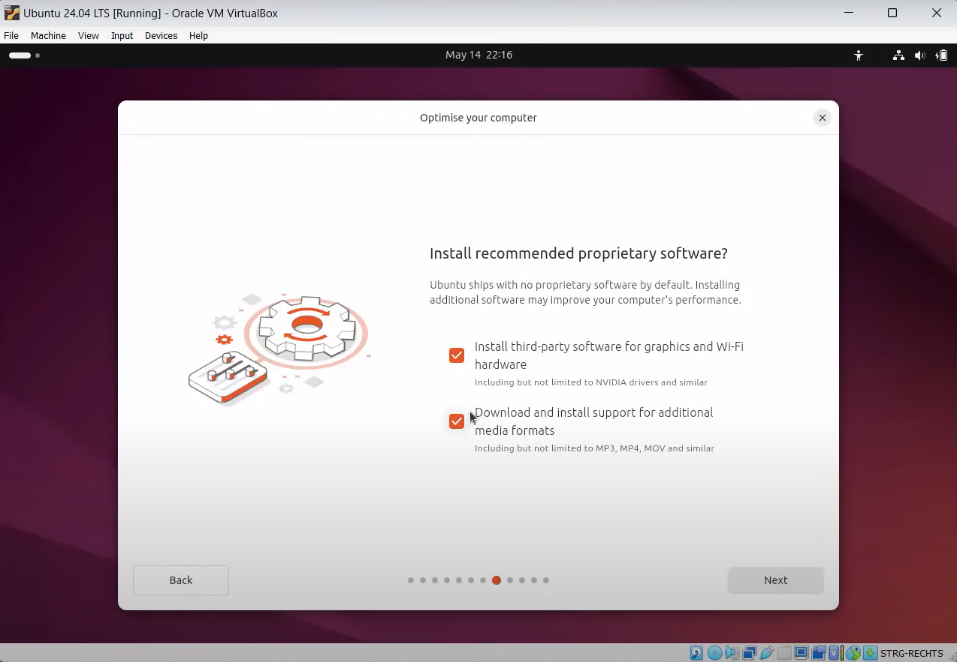

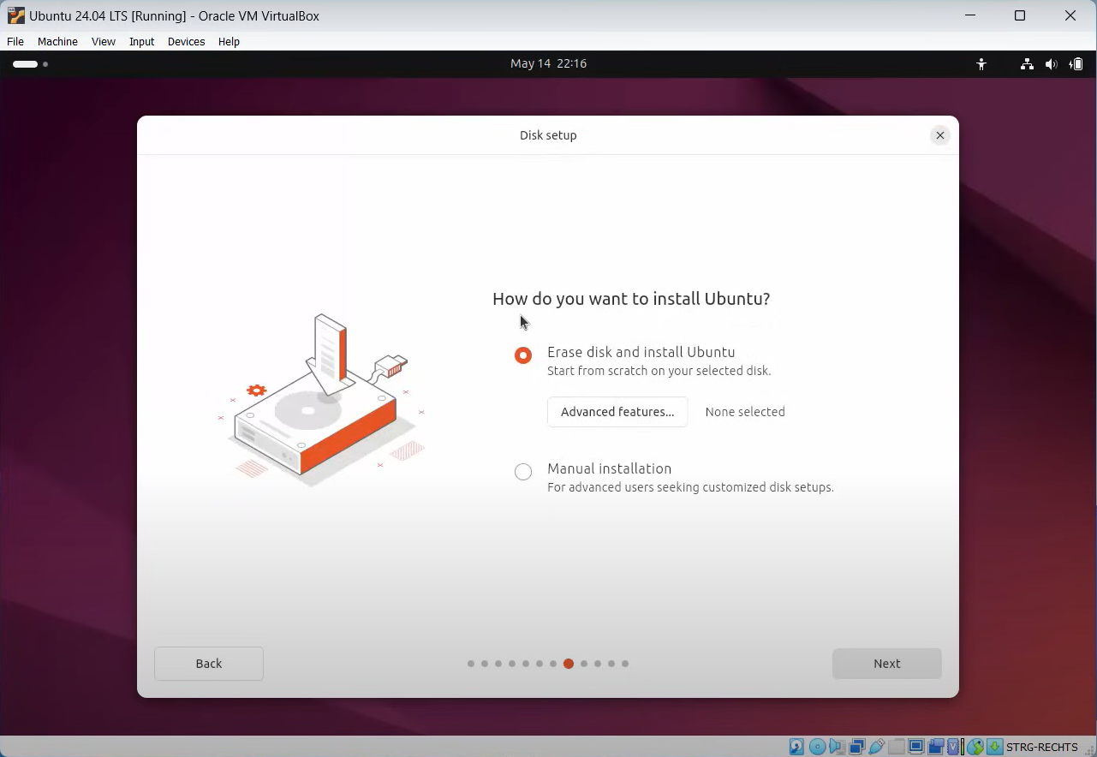

Create account by providing username and strong password.

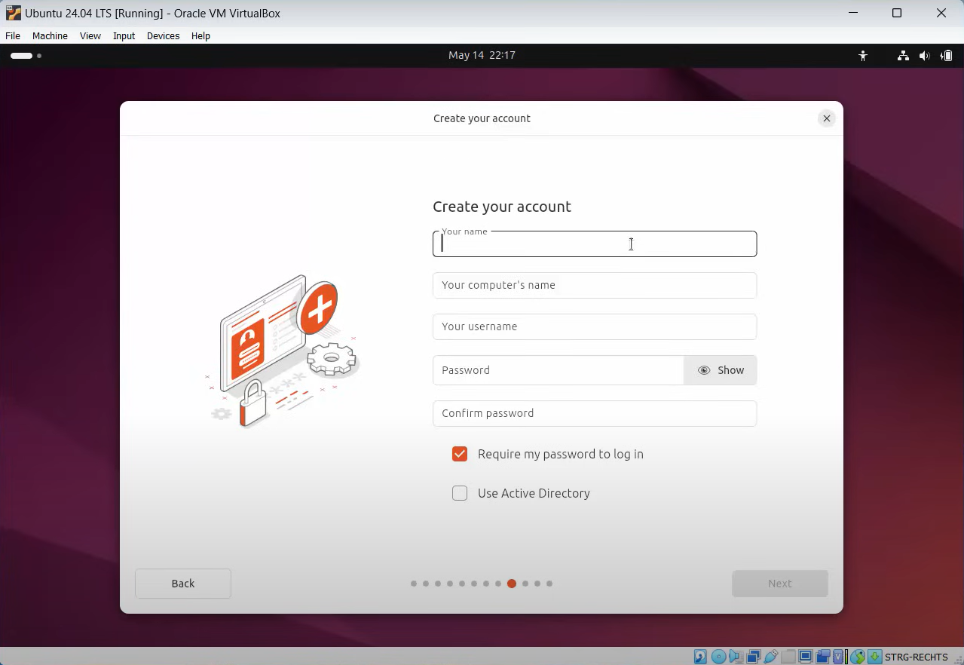

Lastly, press the “install” button to install the Ubuntu on your system.

